**Application of Transformer Architecture in Option Portfolio Arbitrage**

**Yiwei Qi**

ABSTRACT

The study focuses on predicting the dynamics of the options market using the Transformer model, especially predicting the afternoon's price movement range based on the significance of price regression in the morning. By combining the morning trend significance, the midday volume-weighted average price (VWAP), and the morning trading volume, the model aims to provide options investors with a more precise and dynamic market forecasting tool. The research also examines the performance of various machine learning models in predicting stock and options market volatility. It finds that while traditional Artificial Neural Networks (ANN) perform well on small-scale datasets, Transformer models have potential advantages in handling sequential data and capturing temporal dependencies. The study indicates the importance of considering data characteristics and available resources when choosing machine learning models and underscores the research value of Transformer architecture applications.

Keywords: Transformer model, options investment, market prediction, machine learning, stock price volatility, sequential data processing.

1. INTRODUCTION

Optimizing options investment strategies has always been a hot topic in the field of finance. With the increasingly widespread application of machine learning and deep learning technologies in financial forecasting, researchers have begun to explore using these advanced techniques to improve the management and decision-making processes of options portfolios. Particularly, Transformer models have attracted attention due to their advantages in handling time series data, offering new perspectives for financial market analysis. This paper focuses on an innovative application, aiming to use Transformer models to predict the dynamic changes in the options market.

Market dynamics are a key factor influencing investment decisions, especially in a high-frequency trading environment. In such settings, even very short periods of market behavior can significantly impact investment outcomes. One of the main innovations of this paper is the introduction of a new concept - using the significance of price regression in the morning as a binary variable (0-1 variable) to predict the price movement range in the afternoon. The essence of this approach lies in identifying and utilizing the predictive power of market behavior in the morning for the afternoon market trend.

The proposition of this method is based on a deep understanding of the intrinsic logic of market behavior: the trend and oscillation of the market in the morning could be indicative of the afternoon's market movement. For instance, a significant trend in the morning might suggest a continuation or reversal in the afternoon market. By incorporating the morning trend significance as a predictive variable, we can more accurately forecast the market movement in the afternoon.

On this basis, we adopt the Transformer model to process and analyze this relationship. The strength of the Transformer model lies in its ability to handle long time series data and effectively capture key information in the time series through its attention mechanism. Combining the morning's trend significance (as a 0-1 variable) with other important market indicators, such as the volume-weighted average price (VWAP) at noon and the morning trading volume, our model aims to provide options investors with a more precise and dynamic market forecasting tool.

In summary, this paper aims to explore a new method that combines Transformer models with market time series data, to enhance the effectiveness and accuracy of options investment strategies. Through this innovative approach, we hope to provide options investors with a more robust decision-support tool, thereby achieving better performance in the volatile financial market.

1. RELATED WORK

The Transformer model, since its introduction by Vaswani et al. (2017)[1], has revolutionized the field of natural language processing (NLP). The core of the Transformer model is its self-attention mechanism, which allows the model to simultaneously focus on all positions in a sequence when processing sequential data, effectively capturing long-distance dependencies. Compared to traditional Recurrent Neural Networks (RNNs) and Long Short-Term Memory Networks (LSTMs), Transformers demonstrate higher efficiency and accuracy in processing large-scale datasets.

Subsequently, scholars have extensively explored the application of the Transformer model, with financial market prediction being a significant area of focus. In 2023, Wang[2] proposed a combination of BiLSTM and an improved Transformer, which effectively enhances the accuracy of stock price prediction, especially in handling nonlinear and non-stationary financial time series data. Hu X(2021)[3] utilized the Temporal Fusion Transformer to predict stock prices, offering a new perspective for complex financial time series analysis by effectively integrating data across different time scales. Chaojie Wang(2022) [4]utilize the latest deep learning framework, Transformer, to predict the stock market index. Linyi Yang et al.(2022)[5] describes a numeric-oriented hierarchical transformer model (NumHTML) to predict stock returns, and financial risk using multi-modal aligned earnings calls data by taking advantage of the different categories of numbers (monetary, temporal, percentages etc.) and their magnitude. Fu et al. (2023)[6] employed a Transformer model combined with Long Short-Term Memory Networks (LSTM) and attention mechanisms to predict IBM stock prices, demonstrating the effectiveness of deep learning models in financial time series forecasting. Lai et at. (2023) [7]suggested that employing a differential Transformer neural network model can effectively extract key features from high-frequency stock market data, which is crucial for predicting short-term price fluctuations. While validating the effectiveness of Transformer models in financial markets, some scholars sought technical improvements in the field of financial forecasting. Jaemin Yoo et al.(2021)[8] correlated multiple stocks for accurate stock movement prediction via Data-Axis Transformer with Multi-Level Contexts. Daiya D (2021) [9]proved that a multimodal learning approach combining financial indicators and news data significantly enhances stock market prediction performance. Q. Zhang et al (2022)[10] showed that attention mechanisms enable models to more effectively capture long-term dependencies and key trends in stock price movements. Lin et al. (2022)[11] introduced the Kernel-based Hybrid Interpretable Transformer (KHIT) model, which improves the accuracy of stock movement predictions by combining adaptive re-standardization kernel functions and multi-order differential sequence loss functions. Bing Yang(2022)[12] proposes an end-to-end model called DRL-UTrans for learning a single stock trading strategy that combines deep reinforcement learning, transformer layers. Lee T(2023)[13] utilized a multimodal fusion Transformer model to classify and predict stock trends, improving accuracy by integrating macroeconomic indicators and stock price data. Feng Zhou(2023)[14] proposed an adaptive timing encoding mechanism based Transformer with multi-source heterogeneous information fusion.

Research on Transformer models has extended to the options market, characterized by leverage, time value, and volatility (Hull, J.C., 2003[15]). Ronanki et al(2017)[16] pointed out that the uncertainty and volatility of the options market pose higher demands on the predictive capabilities of models, especially when considering market events and the unique dynamics of options. In 2022, Chullamonthon[17] explored the application of the Transformer model in detecting stock price manipulation in the Stock Exchange of Thailand, confirming the potential of Transformer models in handling complex financial datasets.

In summary, current research indicates that Transformer models and their variants show tremendous potential in financial market forecasting, particularly in the stock and options markets. These models effectively process large-scale time series data and capture complex data features, providing new tools and perspectives for financial market analysis and prediction. We will continue to research the application of Transformer models in the stock and options markets, using them to analyze the volatility range of stock time series data and help construct valuable options portfolios.

1. PROBLEM FORMULATION

In the realm of financial markets, particularly in options trading, the ability to accurately forecast stock price movements is crucial. Our research focuses on utilizing the predictive power of stock price volatility to construct options portfolios. Our objective is to guide the rational selling of options portfolios by leveraging the relationship between stock price movements in the morning and subsequent changes in the afternoon. This approach relies on a deep understanding of the intraday volatility of stocks and its impact on the afternoon's closing price relative to the opening price.

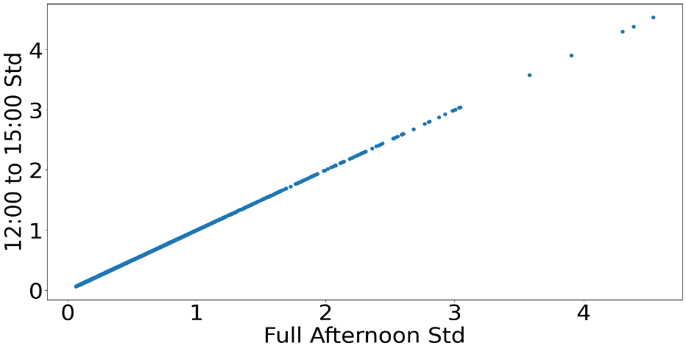Our data is sourced from the SPDR S&P 500 ETF Trust, spanning from 2018 to 2023, with a focus on intraday price movement(https://www.alphavantage.co/documentation/). Due to the large size of the data set, we randomly sampled 1% of the original data for study. We firstly conducted a correlation analysis of all variables in the data.

Figure 1Full Afternoon Std & 12:00 to 15:00 Std

In our study, we divided the trading day into two distinct sessions: morning (09:30 to 12:00) and afternoon (12:01 to 16:00), and conducted a grouped analysis for each period. By calculating the total trading volume, lowest and highest prices, and the standard deviation of the closing price for each session, we gained deeper insights into the market's volatility. Specifically, we calculated the absolute volatility in the morning (absVxD) and the volume-weighted average price (VWAP) at noon, as well as the price shifts during the morning and afternoon sessions. These calculations aimed to capture market dynamics and understand the trends in price changes. The analysis revealed a significant end-of-day amplification effect, where price volatility tends to be more pronounced at the end of the trading day. Specifically, we observed that the standard deviation of prices from noon to 3 PM is typically lower than that from noon to 4 PM. This finding suggests that price fluctuations are more intense towards the end of the trading day compared to the entire afternoon session.

Figure 2Full Afternoon Std & 12:00 to 15:00 Std

Additionally, we calculated the price shifts for both the morning and afternoon sessions. This involved both an absolute and relative measure of the shifts, comparing the last VWAP of the morning to the opening price, and the closing price of the afternoon session to the VWAP at noon. To better visualize and analyze these relationships, we created scatter plots comparing the noon VWAP with the afternoon's lowest and highest prices. This graphical representation highlighted the correlation between the median morning VWAP and the extremities of prices in the afternoon session.

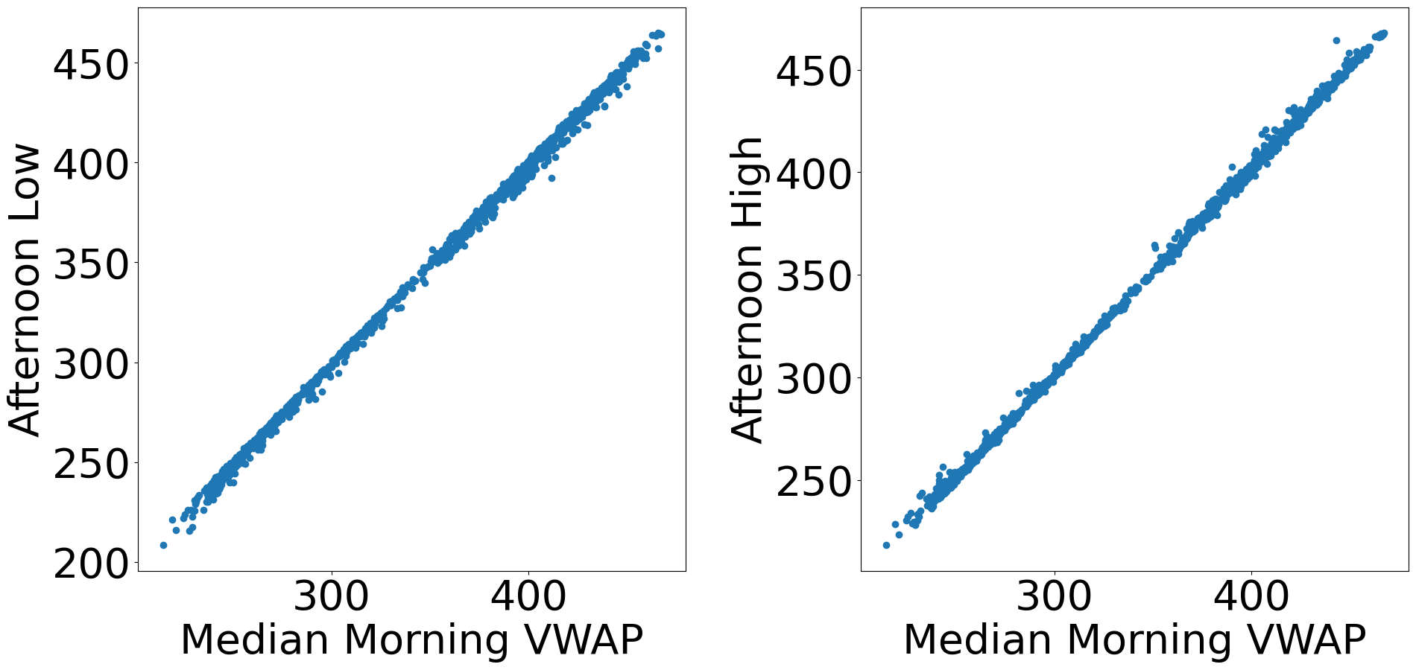

Figure 3 Median Morning VWAP&Afternoon Low/High

Thus, we retained the morning's VWAP (Volume Weighted Average Price), morning trading volume, and the sum of the product of morning trading volume and price per minute as independent variables. Controlling for the morning price trend, we deployed a Transformer-based model, leveraging its capability to process sequential data and capture complex patterns in stock price movements, to predict afternoon price changes, thereby assisting in the construction of options contracts.

This method aims to refine the decision-making process in options trading through the introduction of a data-driven analytical approach. By accurately predicting afternoon price changes based on morning performance, investors can make more informed decisions about which options to sell, effectively balancing risk and reward. This approach not only enhances profitability but also provides new tools and perspectives for a broader understanding of stock market dynamics, particularly in the context of intraday trading.

1. PROPOSED METHOD

Our model is based on the Transformer architecture, which is an excellent tool for processing sequential data. This model combines the powerful sequential processing capability of the Transformer with the nonlinear learning ability of MLP (Multilayer Perceptron). The TransformerMLPRegressionModel class now includes a custom PositionalEncoding subclass and multiple parameters, such as input size, number of heads, number of layers, and the sizes of MLP layers. In our study, the optimization of model parameters was achieved through a random search process. We conducted random searches on predefined parameter distributions, including the number of heads, number of layers, MLP size, and learning rate. Various combinations were experimented with, and their performance was systematically evaluated based on loss metrics. For each set of parameters, the training function was iteratively run, with the model's performance assessed at each epoch. This process is similar to the parameter optimization method described in Ronanki (2017). Through this approach, we were able to identify the best set of parameters that resulted in the lowest loss, thereby enhancing the predictive accuracy of our model.

Thus, in our configuration, the model comprises four parts: the input size is set to 4, considering our four main features. The encoder layers use a dropout rate of 0.4 and a dim_feedforward of 512, aiming to enhance the model's ability to fit complex data and prevent overfitting (Srivastava et al., 2014[18]). The MLP part includes a decreasing layer structure [128, 64, 32, 16], which helps to refine and compress the features extracted from the Transformer encoder gradually (Goodfellow et al., 2016[19]).

Key concepts in the Transformer model include the self-attention mechanism and positional encoding. The self-attention mechanism can be expressed as:

$$Attention\left(Q,K,V\right)=softmax\left(\frac{QK^{T}}{\sqrt{d_{k}}}\right)V$$

$Q,K,V$ represent the query, key, and value matrices, respectively, and $d_{k}$ is the dimension of the key (Vaswani et al., 2017). This mechanism allows the model to pay different levels of attention to each position in the input sequence, thereby effectively capturing long-term dependencies.

Positional encoding uses a combination of sine and cosine functions to provide a unique encoding for each position in the sequence:

$$PE_{(pos,2i)}=sin⁡(\frac{pos}{{{10000}^{2i}}/{d_{model}}})$$

$$PE_{(pos,2i+1)}=cos⁡(\frac{pos}{{{10000}^{2i}}/{d_{model}}})$$

Here, $pos$ is the position, $i$ is the dimension, and $d_{model}$ is the dimension of the model. This encoding method gives the model a sense of time, which is crucial for processing time-series data.

1. COMPARISON AND CONCLUSION

In our research, we comprehensively employed various machine learning models to predict afternoon shifts in the stock market, thus exploring the performance of different models in forecasting stock and options market volatility. Drawing on the research design by Alawadhi et al. (2023)[20], our methodology encompassed a range of models, from SGDRegressor and support vector machines (SVM) to more complex Transformer and artificial neural network (ANN) models. Each model offered insights from different perspectives on the data.

In our experiments, SGDRegressor and SVM performed poorly in predicting afternoon shifts in the stock market. This may be due to limitations of these models in handling the complexity and non-linear relationships in stock market data. On the other hand, k-nearest neighbors (KNN), decision trees, random forests, and random undersampling boost (RUSBoost) models, while performing well on the training set, exhibited signs of overfitting on the validation and test sets. This suggests that these models may have overlearned specific features from the training data without abstracting patterns that can generalize to new data.

In contrast, Transformer models and random forests demonstrated a compromise in our experiments. Transformer models are renowned for their ability to handle sequential data and capture temporal dependencies, but in our experiments, they did not show superior performance over traditional random forests. This could be because we used a subsample of only 1% of the original data to ensure the models could run on hardware with limited capabilities, thus restricting the Transformer model's potential to learn and adapt to the data. In situations with limited data, the complexity of Transformer models may not have been fully exploited.

Table 1 Result Comparison

|  |  |  |  |
| --- | --- | --- | --- |
|  | Performance | | |
| MSE | R-Square | Loss Function |
| *SGDRegressor* | 7.276 | -0.001 | - |
| *K-Nearest Neighbors* | 4.503e-33 | 1.000 | - |
| *Decision Trees* | 2.162e-18 | 1.000 | - |
| *Random Forest* | 6.520 | 0.103 | - |
| *Extra Trees* | 2.790e-28 | 1.000 | - |
| *Random Under-Sampling Boosting* | 1.196e-29 | 1.000 | - |
| *ANN* | 0.734 | 0.899 | - |
| *Radial Basis Function* | 6.609 | 0.091 | - |
| *SVM-Two Linear* | 7.303 | -0.004 | - |
| *SVM-Sigmoid* | 100349031.439 | -13801235.457 | - |
| *SVM-Polynomial* | 7.320 | -0.007 | - |
| *Transformer* | 6.689 | -0.004 | 1.382-1.384 |

To expand the working sequence length of the Transformer model and enhance its performance in stock market prediction, it is crucial first to consider increasing the data volume. In the experiment of the paper, the use of only 1% of the original data samples restricted the model's ability to learn and adapt to the data. By augmenting the sample size, the Transformer can more effectively capture complex patterns and long-term dependencies within the data, thereby improving its predictive accuracy. Additionally, optimizing the model structure is of great importance. Adjustments can be made to the model parameters, such as the number of heads, layers, and the size of MLP layers, to accommodate longer sequences. Utilizing model parameter optimization techniques, like random search, can help in identifying the optimal combination of parameters, thus enhancing the model's capability to handle long sequences. Concurrently, considering the use of efficient hardware resources is a significant aspect of boosting model performance. Given the high computational resource demands of the Transformer model, employing more powerful hardware can facilitate the processing of longer sequences, thereby overcoming limitations in memory and computational capacity. In terms of data preprocessing, appropriately handling long sequences, such as through segmentation or dimensionality reduction, can alleviate the load on the model and enhance its efficiency in processing long sequential data.

Traditional ANN models exhibited excellent performance in our experiments. This could be attributed to the higher flexibility and adaptability of ANN models when dealing with such data. In the case of complex and pattern-rich stock market data, ANNs can adjust their neural network structures more effectively for learning and prediction. Additionally, ANNs are typically easier to train on relatively small datasets and have better capturing capabilities for non-linear relationships in the data, which may be a key factor in their outstanding performance in our experiments.

To summarize, while Transformer models excel in certain domains, for our specific problem of stock market prediction, they require a substantial amount of data and computational power for fine-tuning. Under the constraints of small-scale data and limited computational resources, ANN is likely to perform unexpectedly well. This finding emphasizes the importance of considering data characteristics and available resources when choosing machine learning models tailored to specific problems. It also reminds us that when applying advanced machine learning techniques, experimental conditions and data limitations must be taken into account, as these factors can significantly impact model performance. But this does not mean that prediction using Transformer is a failure. Zhuoran Lin(2023)[21] indicate that although LSTM outperforms Transformer in terms of Mean Absolute Error and Mean Squared Error, it tends to simplify the problem by falling into the trap of autocorrelation. Conversely, Transformer learns unique dependencies, demonstrating potential for capturing the internal relationships of securities price changes. Harsimrat Kaeley et al.(2023)[22] also pointed out that Transformer based model avoid the limitations of Neural Networks, such as gradient vanish and long-term dependencies being lost as sequence length increases. Thus, studies on application of Transformer architecture are still valuable.

REFERENCES

[1] Vaswani A, Shazeer N, Parmar N, et al. Attention is all you need[J]. Advances in neural information processing systems, 2017, 30.

[2] Wang S. A Stock Price Prediction Method Based on BiLSTM and Improved Transformer[J]. IEEE Access, 2023.

[3] Hu X. Stock price prediction based on temporal fusion transformer[C]//2021 3rd International Conference on Machine Learning, Big Data and Business Intelligence (MLBDBI). IEEE, 2021: 60-66.

[4] Wang C, Chen Y, Zhang S, et al. Stock market index prediction using deep Transformer model[J]. Expert Systems with Applications, 2022, 208: 118128.

[5] Yang L, Li J, Dong R, et al. NumHTML: Numeric-Oriented Hierarchical Transformer Model for Multi-task Financial Forecasting[C]//Proceedings of the AAAI Conference on Artificial Intelligence. 2022, 36(10): 11604-11612.

[6] Fu S, Tang Z, Li J. IBM Stock Forecast Using LSTM, GRU, Attention and Transformer Models[C]//2023 IEEE International Conference on Control, Electronics and Computer Technology (ICCECT). IEEE, 2023: 167-172.

[7] Lai S, Wang M, Zhao S, et al. Predicting high-frequency stock movement with differential transformer neural network[J]. Electronics, 2023, 12(13): 2943.

[8] Yoo J, Soun Y, Park Y, et al. Accurate multivariate stock movement prediction via data-axis transformer with multi-level contexts[C]//Proceedings of the 27th ACM SIGKDD Conference on Knowledge Discovery & Data Mining. 2021: 2037-2045.

[9] Daiya D, Lin C. Stock movement prediction and portfolio management via multimodal learning with transformer[C]//ICASSP 2021-2021 IEEE International Conference on Acoustics, Speech and Signal Processing (ICASSP). IEEE, 2021: 3305-3309.

[10] Zhang Q, Qin C, Zhang Y, et al. Transformer-based attention network for stock movement prediction[J]. Expert Systems with Applications, 2022, 202: 117239.

[11] Lin F, Li P, Lin Y, et al. Kernel-based Hybrid Interpretable Transformer for High-frequency Stock Movement Prediction[C]//2022 IEEE International Conference on Data Mining (ICDM). IEEE, 2022: 241-250.

[12] Yang B, Liang T, Xiong J, et al. Deep reinforcement learning based on transformer and U-Net framework for stock trading[J]. Knowledge-Based Systems, 2023, 262: 110211.

[13] Lee T W, Teisseyre P, Lee J. Effective Exploitation of Macroeconomic Indicators for Stock Direction Classification Using the Multimodal Fusion Transformer[J]. IEEE Access, 2023, 11: 10275-10287.

[14] Zhou F, Zhang Q, Zhu Y, et al. T2V_TF: An adaptive timing encoding mechanism based Transformer with multi-source heterogeneous information fusion for portfolio management: A case of the Chinese A50 stocks[J]. Expert Systems with Applications, 2023, 213: 119020.

[15] Hull J C. Options futures and other derivatives[M]. Pearson Education India, 2003.

[16] Ronanki D, Williamson S S. Evolution of power converter topologies and technical considerations of power electronic transformer-based rolling stock architectures[J]. IEEE Transactions on Transportation Electrification, 2017, 4(1): 211-219.

[17] Chullamonthon P, Tangamchit P. A transformer model for stock price manipulation detection in the stock exchange of Thailand[C]//2022 19th International Conference on Electrical Engineering/Electronics, Computer, Telecommunications and Information Technology (ECTI-CON). IEEE, 2022: 1-4.

[18] Srivastava N, Hinton G, Krizhevsky A, et al. Dropout: a simple way to prevent neural networks from overfitting[J]. The journal of machine learning research, 2014, 15(1): 1929-1958.

[19] Goodfellow I, Bengio Y, Courville A. Deep learning[M]. MIT press, 2016.

[20] Alawadhi A, Karpoff J, Koski J L, et al. The prevalence and price distorting effects of undetected financial misrepresentation: empirical evidence[R]. Working Paper. Available from: https://ssrn. com/abst r act= 3532053 [Accessed 2nd May 2023], 2023.

[21] Lin Z. Comparative Study of LSTM and Transformer for A-Share Stock Price Prediction[C]//2023 2nd International Conference on Artificial Intelligence, Internet and Digital Economy (ICAID 2023). Atlantis Press, 2023: 72-82.

[22] Kaeley H, Qiao Y, Bagherzadeh N. Support for Stock Trend Prediction Using Transformers and Sentiment Analysis[J]. arXiv preprint arXiv:2305.14368, 2023.

1. Vaswani A, Shazeer N, Parmar N, et al. Attention is all you need[J]. Advances in neural information processing systems, 2017, 30.
2. Wang S. A Stock Price Prediction Method Based on BiLSTM and Improved Transformer[J]. IEEE Access, 2023.
3. Hu X. Stock price prediction based on temporal fusion transformer[C]//2021 3rd International Conference on Machine Learning, Big Data and Business Intelligence (MLBDBI). IEEE, 2021: 60-66.
4. Wang C, Chen Y, Zhang S, et al. Stock market index prediction using deep Transformer model[J]. Expert Systems with Applications, 2022, 208: 118128.
5. Yang L, Li J, Dong R, et al. NumHTML: Numeric-Oriented Hierarchical Transformer Model for Multi-task Financial Forecasting[C]//Proceedings of the AAAI Conference on Artificial Intelligence. 2022, 36(10): 11604-11612.
6. Fu S, Tang Z, Li J. IBM Stock Forecast Using LSTM, GRU, Attention and Transformer Models[C]//2023 IEEE International Conference on Control, Electronics and Computer Technology (ICCECT). IEEE, 2023: 167-172.
7. Lai S, Wang M, Zhao S, et al. Predicting high-frequency stock movement with differential transformer neural network[J]. Electronics, 2023, 12(13): 2943.
8. Yoo J, Soun Y, Park Y, et al. Accurate multivariate stock movement prediction via data-axis transformer with multi-level contexts[C]//Proceedings of the 27th ACM SIGKDD Conference on Knowledge Discovery & Data Mining. 2021: 2037-2045.
9. Daiya D, Lin C. Stock movement prediction and portfolio management via multimodal learning with transformer[C]//ICASSP 2021-2021 IEEE International Conference on Acoustics, Speech and Signal Processing (ICASSP). IEEE, 2021: 3305-3309.
10. Zhang Q, Qin C, Zhang Y, et al. Transformer-based attention network for stock movement prediction[J]. Expert Systems with Applications, 2022, 202: 117239.
11. Lin F, Li P, Lin Y, et al. Kernel-based Hybrid Interpretable Transformer for High-frequency Stock Movement Prediction[C]//2022 IEEE International Conference on Data Mining (ICDM). IEEE, 2022: 241-250.
12. Yang B, Liang T, Xiong J, et al. Deep reinforcement learning based on transformer and U-Net framework for stock trading[J]. Knowledge-Based Systems, 2023, 262: 110211.
13. Lee T W, Teisseyre P, Lee J. Effective Exploitation of Macroeconomic Indicators for Stock Direction Classification Using the Multimodal Fusion Transformer[J]. IEEE Access, 2023, 11: 10275-10287.
14. Zhou F, Zhang Q, Zhu Y, et al. T2V_TF: An adaptive timing encoding mechanism based Transformer with multi-source heterogeneous information fusion for portfolio management: A case of the Chinese A50 stocks[J]. Expert Systems with Applications, 2023, 213: 119020.
15. Hull J C. Options futures and other derivatives[M]. Pearson Education India, 2003.
16. Ronanki D, Williamson S S. Evolution of power converter topologies and technical considerations of power electronic transformer-based rolling stock architectures[J]. IEEE Transactions on Transportation Electrification, 2017, 4(1): 211-219.
17. Chullamonthon P, Tangamchit P. A transformer model for stock price manipulation detection in the stock exchange of Thailand[C]//2022 19th International Conference on Electrical Engineering/Electronics, Computer, Telecommunications and Information Technology (ECTI-CON). IEEE, 2022: 1-4.
18. Srivastava N, Hinton G, Krizhevsky A, et al. Dropout: a simple way to prevent neural networks from overfitting[J]. The journal of machine learning research, 2014, 15(1): 1929-1958.
19. Goodfellow I, Bengio Y, Courville A. Deep learning[M]. MIT press, 2016.
20. Alawadhi A, Karpoff J, Koski J L, et al. The prevalence and price distorting effects of undetected financial misrepresentation: empirical evidence[R]. Working Paper. Available from: https://ssrn. com/abst r act= 3532053 [Accessed 2nd May 2023], 2023.
21. Lin Z. Comparative Study of LSTM and Transformer for A-Share Stock Price Prediction[C]//2023 2nd International Conference on Artificial Intelligence, Internet and Digital Economy (ICAID 2023). Atlantis Press, 2023: 72-82.
22. Kaeley H, Qiao Y, Bagherzadeh N. Support for Stock Trend Prediction Using Transformers and Sentiment Analysis[J]. arXiv preprint arXiv:2305.14368, 2023.